*Motocross Madness*

# Overview/Theme

## Idea Summary

A motocross game set in the mountains. Player goes through difficult road tracks in the mountains and survive the curvy paths.

## Goal

What's the ultimate aim of the player playing this game? Why will it be fun, entertaining or satisfying?

Ans: It will be an adrenaline pumped motocross driving game. It will give user a sense of excitement and joy when he rides through the mountains.

# 

# Mock Ups

Use mockups that you have made, stock images, game screenshots or doodles to showcase how the game works. The quality / accuracy of the image doesn’t matter, it can be a badly drawn doodle but should explain the core game.

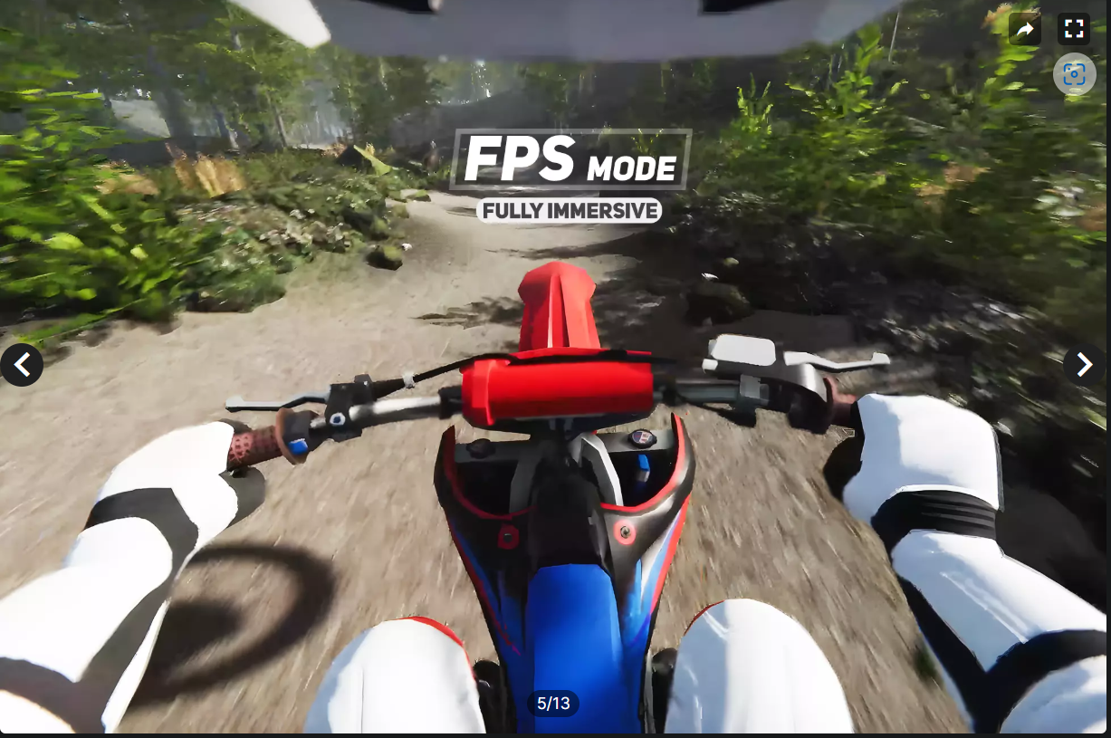

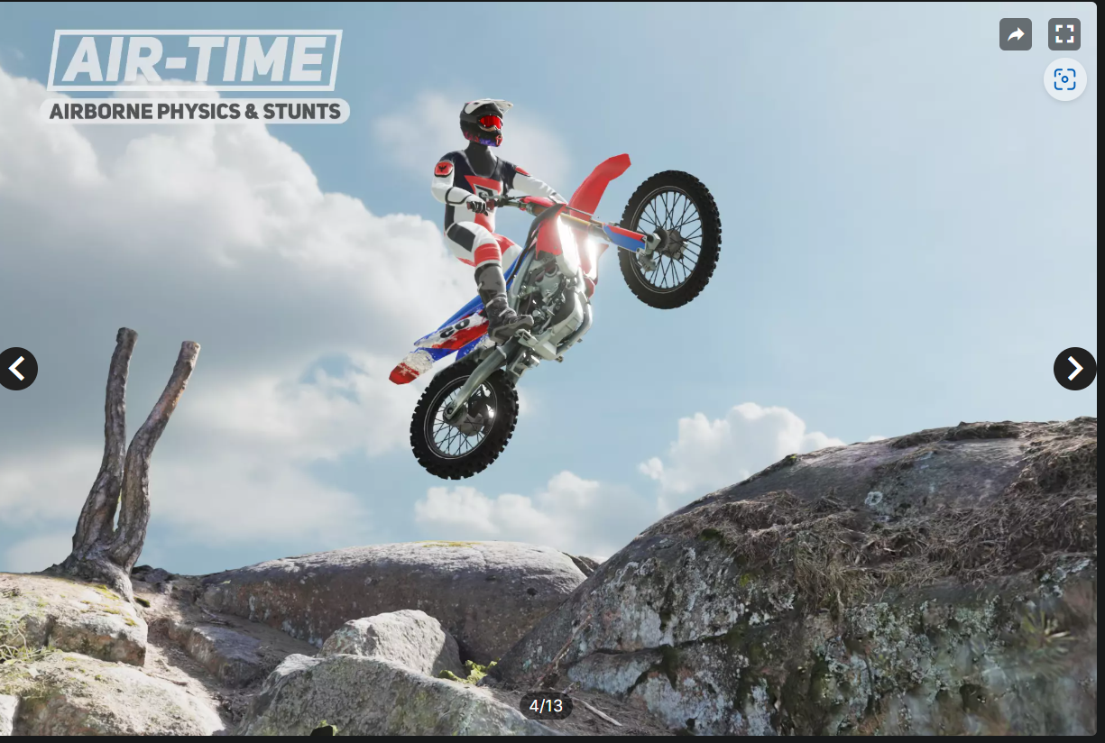

# References (Optional)

[Simple Motocross Physics | Physics | Unity Asset Store](https://assetstore.unity.com/packages/tools/physics/simple-motocross-physics-221408)

# Art Style (check any number of boxes that apply)

* 3D
* High Poly
* Photo Realism

# Look & Feel / Camera

* First Person
* Third Person
* Over The Shoulder.

# Mechanic

## Controls

* Landscape
* Tap
* Hold
* Release
* Other

## Core Loop (Feel Free to Replace the Diagram Below)

Player taps to start ………..

Player is spawned in a scene and timer starts.

Player tries to complete the track and finish in given time. Else he loses the game.

Player completes the level and next level is loaded

# 

# Progression

* Level Based
* Score Based
* Upgrade Based
* Star Based